Accellion User Guide

What Is Secure File Transfer?
Secure file transfer is a service that allows for the secure sharing of files between users within Harvard University and outside. It is sometimes referred to as Accellion.

How do I log in?
Go to https://fta.fas.harvard.edu (FAS Faculty/Staff/Student) or https://fta.cadm.harvard.edu (Central Administration and supported staff) and enter your full email address and password.

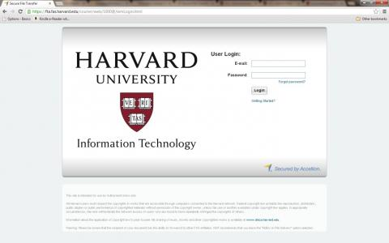

How do I send a file?
To send a file, login as described above. After logging in, a message alerting you that your browser is about to run a little program called an applet will appear. The message will be similar to the one below but the exact appearance may vary depending on which web browser you are using. Click Run to continue.
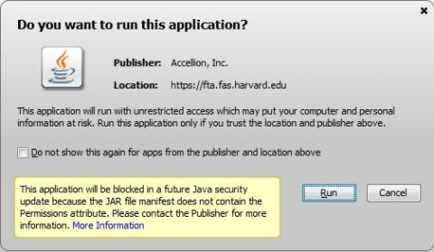
A new page with tabs will load, with the Send File tab at the top.
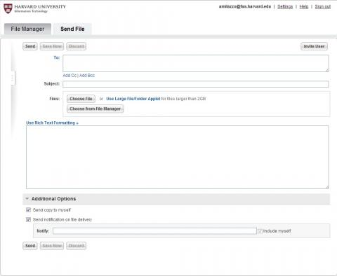
Prepare your file by composing a message on this page, and then attaching the file as if you were using an email program. Once you have composed the e-mail and attached the file, click Send. The file will upload to the Secure File Transfer server, and then the email will be sent with a secure link to the file. Your recipient(s) will get an email message with this link, which they can use to retrieve the file (see below).

How do I receive a file?
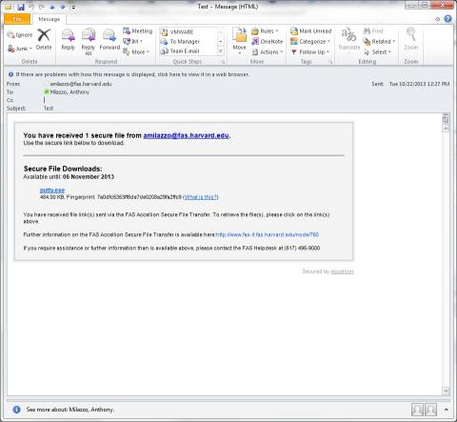
The recipient of a file transfer will receive an email that includes a secure link. If they already have an account on the Accellion service, they can click on the secure link to download the file. If the recipient is a first time user they will be prompted to create an Accellion account before they can proceed with the download.

